Nathan Villicaña-Shaw

November 15, 2015

**Wave Cave Proposal: *Cathode Ray Tubes***

Four CRT TV’s are set up each on its own small TV stand in a semicircle. In front of each TV is a Nintendo hardware emulator (Retron) turned inside out. The TV’s and the Retrons are all connected in one large 8bit-glitch feedback loop. As the interactee approaches one of the TV’s they are able to lay their hands on the bare circuit board; inserting their body into the installations circuitry, effecting the video on all four of the displays as the Video from each of the Retrons is sonified in real time using custom video decoding circuitry.

**Project Description**

Four Retron NES hardware emulation consoles are removed from their original casings and repackaged in clear acrylic boxes. In the repackaging all the critical circuit boards are exposed to the outside of the case while the control ports and cartridge slot are removed (effectively turning the device inside out).

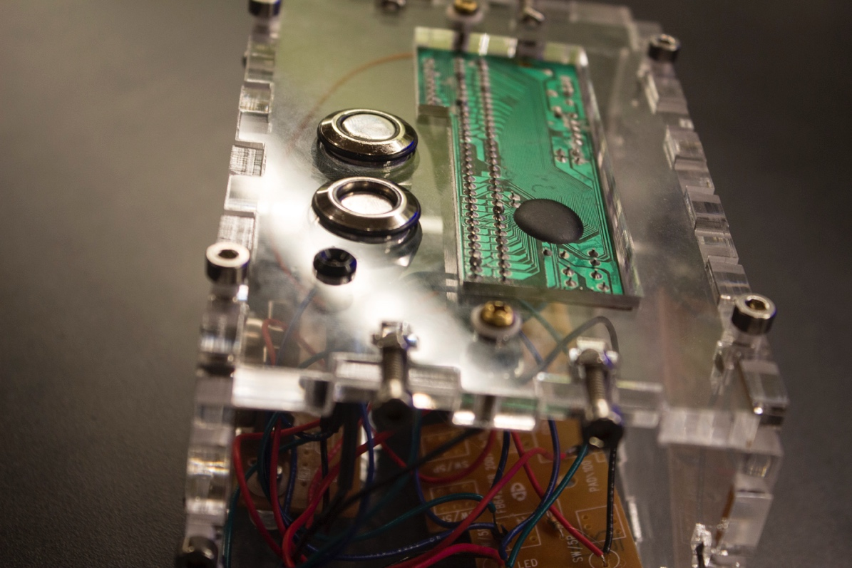

**Image 1:** first-run Retrono (installation versions will not have buttons only the circuit board)

When the Retron consoles are turned on with no game cartridge inserted the circuitry ‘floats’ creating interesting simple geometric glitch displays (see image 2). The pins are floating without any proper pull-up or pull-down mechanisms and the circuit becomes “live” and extremely susceptible to outside interference.



**Image 2:** Example output from “live” Retron

Each of the Retrons are placed in front of a CRT TV (close enough for the CRT’s electrical field to start to interfere with the Retron circuitry). Whatever is displayed on the TV starts to directly effect the output of the Retron. While the audio outputted from each Retron does go to the TV it sits in front of, the Video output is sent to the next TV in the installation as well as being sent to custom video to audio circuitry. (see electrical diagram below) This wiring schema effectively connects all four TV’s and all four Retons in one large feedback loop.

While the system will generate interesting visuals and sounds on its own, *Cathode Ray Tubes* is an interactive space and interactees are encouraged to “play” the feedback loop. Interactees are able to inject data into the loop by touching one of the exposed circuit boards, if they touch multiple circuit boards at once they are able to create sub-loops as the electricity flows through their bodies (its safe) from one Retron to another. If they touch the TV screens they will temporarily add resistance to the feedback loop by removing the static electricity from the TV which acts as the transfer mechanism between the TV’s and the Retrons. If the interactee is uncomfortable with touching circuit boards or crackling TV screens they can effect the system by simply changing the position of the Retron in relation to the TV as even small adjustments can drastically effect the images produced.

*Cathode Ray Tubes* strives to bring people closer to the technology they use and exploit every day by exposing electronic devices and their internal mechanisms. By visualizing, sonifying and uncovering aspects of electronic circuitry that is usually hidden from our view *Cathode Ray Tubes* allows participants to literally become a part of the circuitry.

Cathode%20Ray%20Tubes%20-%20Gallery%20Layout.ai

Cathode%20Ray%20Tubes%20-%20Electronics%20Diagram.ai

**Links:**

**Cathode Ray Tubes** – POF Videos (so far)

Proof of concert for the feedback loop using two TV’s and two Retrons.

<https://www.youtube.com/watch?v=3WovzVABXLc>

What the video generally looks like that the Retrons create:

<https://vimeo.com/143563194>

**Digital Rain**: Grid of 196 relay switches that created music from the weather reports from around the country in real time.

<https://youtu.be/x87EnplNm88?t=1m15s>

**Toys:** Controlling circuit bent children’s toys with a custom built interface.

<https://www.youtube.com/watch?v=Lxgry-iFIAs>

<https://www.youtube.com/watch?v=jlbxIBrCLqA>

**1990**: Circuit bent SNES’s:

<https://youtu.be/C2SuXUqXMpE?t=23s>

<https://youtu.be/__MrRWzerhc>

**Website:** (somewhat out of date)

<http://bitdeph.com/>

**Bio:**

Nathan Villicaña-Shaw enjoys creating work that explores and questions our ever changing relationship with technology. Nathan’s research focuses on developing and working under his philosophy of OpenHacking which is the creation of art through discoverist methods that utilizes both the exposure of closed systems as well as the creation of inherently open systems with the intention of subversive user interaction as a mechanism for art creation. Nathan spends most of his time creating installation art, building new instruments, programming or hacking electronic systems. Nathan Villicaña-Shaw is a MFA in the MTIID department at CalArts where he obtained his BFA in the same department. Before studying at CalArts Nathan played Bass in various punk and surf bands from the SF East Bay such as The Molestations and The Machetes. You can find out more about Nathan and his past projects on his website bitdeph.com.